32 Stats Video Lecture – inference for a mean in the t dist

1. example: Playing a computer game during lunch affect fullness, memory for lunch, and snack intake
   1. does being distracted during meals make people forget what they’ve eaten? & cause snacking
   2. sample size, 44, 22 men and women
   3. treatment group: allowed to play solitare while eating lunvh
   4. placebo group: given only their lunch and asked to dwell on what they ate as they ate it
   5. both groups were offered biscuits as a snack after lunch
   6. Sample dist: 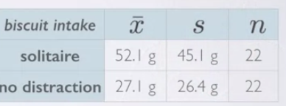
2. Goal: estimate the mean weight of noms
3. first step: calculate the sample error
4. next step: calculate the T value 
5. to calculate the degrees of freedom: $df=n-1$
6. look up the t score on a chart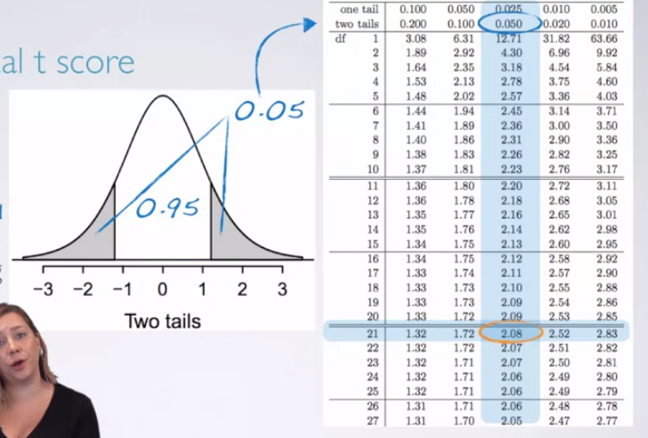
7. or, calculate the score using qt() in R 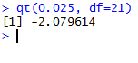
8. 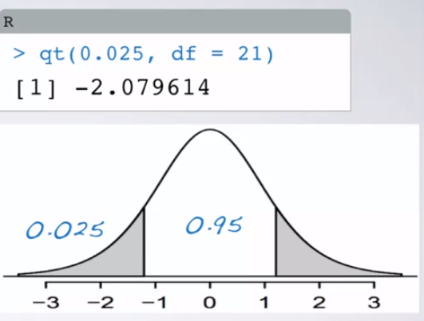
9. 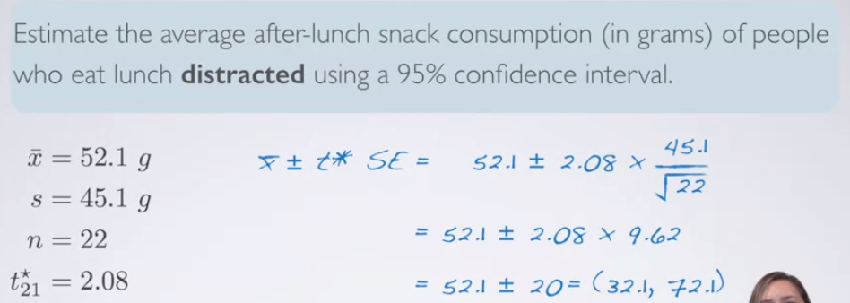
10. Conditions in this experiment
    1. random assignment
    2. 22 is less than 10 percent of the total distracted eater population
    3. there is probably a skew, since the standard dev is so high, and there is a natural cutoff at 0